|  |  |  |  |  |
| --- | --- | --- | --- | --- |
| **TALLER EVALUADO INGLÉS – OCTAVOS - NIVELACIÓN** | | | | **NOTA** |
| **NOMBRE:** | | | 8° |  |
| **MAESTRA ESTEPHANIE MORALES - NATALIA DOMINGUEZ** | **UNIDAD DE NIVELACION** | | | **Ptje ideal: pts** |
| **CONTENIDOS:** instrumentos y géneros musicales. Pasado simple verbos regulares.  **Objetivos de aprendizaje:**  1)Identifica información explicita en texto escrito.  2) Reconoce vocabulario de instrumentos y géneros.  3) Aplica verbos regulares en pasado simple.  **Instrucciones:**  1)Lea atentamente antes de responder.  2) Escriba sus respuestas en la **HOJA DE RESPUESTAS** al final.  3) Para consultas dirigirse al sigte.  Correo: [emorales@donboscoantofagasta.cl](mailto:emorales@donboscoantofagasta.cl) (8A-8B-8C)  Correo: [ndominguez@donboscoantofagasta.cl](mailto:ndominguez@donboscoantofagasta.cl) (8D-8E)  4) Fecha de entrega: **miércoles 25 marzo** | | | | **Ptje Real:** |
|  | |  | | |
| **READING COMPHRENSION** | | | | |

Read the text and answer the questions **from 1 to 6.** ( 6 pts)

***AMY WINEHOUSE***

Amy Jade Winehouse (14 September 1983-23 July 2011) was an English singer-songwriter known for her powerful voice and her eclectic mix of musical genres including R&B, soul and jazz. Winehouse's 2003 first album, Frank, was critically successful in the UK , It was nominated for the Mercury Prize. Her next album, Back to Black, was even more successful. Amy Winehouse became the first British female to win five Grammy in a single night, including three of the "Big Four": Best New Artist, Record of the Year and Song of the Year.

On 14 February 2007, she won a Brit Award for Best British Female Artist; one in 2007 for Best Contemporary Song for "Rehab" , and one in 2008 for Best Song Musically and Lyrically for "Love is a losing Game". The album was the third biggest seller of the 2000s in the United Kingdom. Winehouse's distinctive style of life madeher a muse for fashion designers such as Karl Lagerfeld.

Winehouse's problems with drug, alcohol abuse and violence was regular tabloid news from 2007 until her death. In 2008, Winehouse had a series of health complications.

Amy Winehouse died on 23 July 2011, at her home in London. She was cremated at Golders Green Crematorium. She left millions of fans all around the world.



|  |  |
| --- | --- |
| * 1. What was she known for?      1. her reggae style      2. her powerful voice and her ecletic mix of musical genres      3. her famous song Oops I didn’t again!      4. her first album in 1990. | * 1. What is her second album?      1. Frank      2. Rehab      3. Back to Black      4. Love is a losing game |
| * 1. When did she win a Brit Award for best British female artist?      1. February 14th , 2007      2. March 14th, 2007      3. February 16th , 2006      4. February 14th , 2001 | * 1. What song made her winner of the Brit Award in 2007?      1. Love is a losing game      2. You know I’m no good      3. Back to Black      4. Rehab |
| * 1. What king of problems did she have?      1. alcohol abuse, violence and headaches      2. drugs, alcohol abuse and violence      3. drugs, alcohol abuse and a cold      4. drugs, violence and heart problems | * 1. Where did she die?      1. At her home in California      2. At the hospital in London      3. At the hospital in Washington   D. At her home in London |

MUSICAL INSTRUMENTS

**Look at the pictures and choose the right option. (12 pts)**

[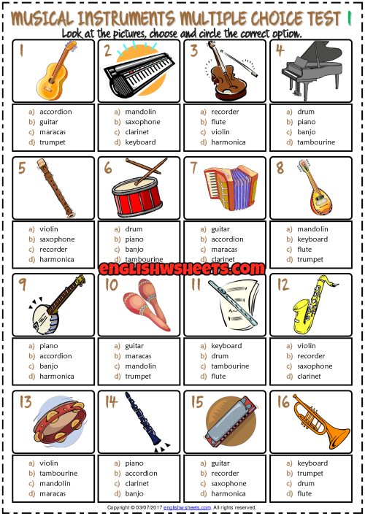](https://www.google.com/url?sa=i&url=https://www.pinterest.it/pin/451978512602128358/&psig=AOvVaw2nFrZzlABgcC1BgrL2WS8b&ust=1584543047028000&source=images&cd=vfe&ved=0CAIQjRxqFwoTCJCRlv3goegCFQAAAAAdAAAAABAD)

**10**

**7**

**8**

**9**

|  |  |  |  |
| --- | --- | --- | --- |
| a) Accordion  b) guitar  c)maracas  d) trumpet | a) mandolin  b) saxophone  c)clarinet  d) keyboard | a) recorder  b) flute  c)violin  d) harmonica | a) drum  b) piano  c)banjo  d) tambourine |

[](https://www.google.com/url?sa=i&url=https://www.pinterest.it/pin/451978512602128358/&psig=AOvVaw2nFrZzlABgcC1BgrL2WS8b&ust=1584543047028000&source=images&cd=vfe&ved=0CAIQjRxqFwoTCJCRlv3goegCFQAAAAAdAAAAABAD)

**14**

**13**

**12**

**11**

|  |  |  |  |
| --- | --- | --- | --- |
| a) violin  b) saxophone  c)recorder  d) harmonica | a) drum  b) piano  c)banjo  d) tambourine | a) guitar  b) accordion  c)maracas  d) clarinet | a) mandolin  b) keyboard  c) flute  d) trumpet |

**16**

[](https://www.google.com/url?sa=i&url=https://www.pinterest.it/pin/451978512602128358/&psig=AOvVaw2nFrZzlABgcC1BgrL2WS8b&ust=1584543047028000&source=images&cd=vfe&ved=0CAIQjRxqFwoTCJCRlv3goegCFQAAAAAdAAAAABAD)

**18**

**17**

**15**

|  |  |  |  |
| --- | --- | --- | --- |
| a) keyboard  b) saxophone  c)banjo  d) harmonica | a) tambourine  b) piano  c)banjo  d) maracas | a) flute  b) trumpet  c)maracas  d) piano | a) banjo  b) keyboard  c) recorder  d) trumpet |

MUSIC GENRES

Look at the Singer/ Band and chooce the correct music genre. (6 pts)

|  |  |
| --- | --- |
| 19) **MICHAEL JASKSON**  [Resultado de imagen de michael jackson](https://www.google.com/url?sa=i&url=https://www.hola.com/biografias/michael-jackson/&psig=AOvVaw1RP7tnc3QybKvQIFk56ZcT&ust=1584544329223000&source=images&cd=vfe&ved=0CAIQjRxqFwoTCIil0OLloegCFQAAAAAdAAAAABAD)  a) pop  b) reggeaton  c) trap  d) k-pop | 20) **BLACK PINK**  [Resultado de imagen de BLACK PINK](https://www.google.com/url?sa=i&url=https://www.soompi.com/es/article/408935wpp/blackpink-anuncia-primer-concierto-seul-la-gira-in-your-area&psig=AOvVaw0s9LKtr18JscZosNeRz4hR&ust=1584544548276000&source=images&cd=vfe&ved=0CAIQjRxqFwoTCPCiv8rmoegCFQAAAAAdAAAAABAD)  a) tropical  b) bachata  c) k-pop  d) samba |
| [Resultado de imagen de BUD BUNNY](https://www.google.com/url?sa=i&url=https://www.buenamusica.com/bad-bunny/biografia&psig=AOvVaw19-MwSMyeQgY0VVSMmUaKD&ust=1584544692439000&source=images&cd=vfe&ved=0CAIQjRxqFwoTCKDqzY_noegCFQAAAAAdAAAAABAD)21) **BUD BUNNY**  a) jazz  b) trap  c) k-pop  d) salsa | [Resultado de imagen de bruno mars](https://www.google.com/url?sa=i&url=https://colectivoexpectador.wordpress.com/2017/11/27/bruno-mars-y-su-importancia-en-la-actualidad/&psig=AOvVaw27w9q-Eds_46xc01npUe5P&ust=1584544888077000&source=images&cd=vfe&ved=0CAIQjRxqFwoTCNCnweznoegCFQAAAAAdAAAAABAD)22) BRUNO MARS  a) country  b) electronic  c) pop  d) salsa |
| [Resultado de imagen de rap cantante famosos](https://www.google.com/url?sa=i&url=http://brandonben10000.blogspot.com/2017/05/cantantes-mas-famosos-del-rap.html&psig=AOvVaw1RjDHdIFDHjWttu5FiQkEO&ust=1584544979439000&source=images&cd=vfe&ved=0CAIQjRxqFwoTCOCagpnooegCFQAAAAAdAAAAABAD)23) **EMINEM**  a) samba  b) rap  c) tropical  d) blues | [Resultado de imagen de queen](https://www.google.com/url?sa=i&url=https://www.infobae.com/america/agencias/2020/01/20/reino-unido-lanza-moneda-conmemorativa-celebrando-a-queen/&psig=AOvVaw1YpTxY4uNODt-daEkeRaTQ&ust=1584545254544000&source=images&cd=vfe&ved=0CAIQjRxqFwoTCNiNlJvpoegCFQAAAAAdAAAAABAD)24) **QUEEN**  a) reggae  b) hip hop  c) tropical  d) rock |

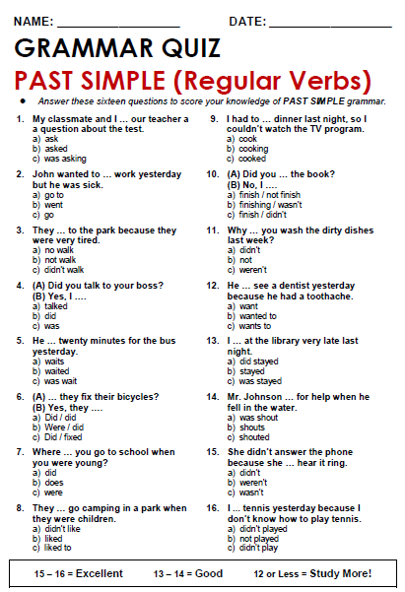

**(16 pts)**

**33)**

**25)**

**34)**

**26)**

**35)**

**27)**

**28)**

**36)**

**37)**

**29)**

**38)**

**30)**

**39)**

**31)**

**32)**

**40)**

HOJA DE RESPUESTA

Escriba sus respuestas aquí. LETRAS EN MAYÚSCULA.

|  |  |  |  |  |  |  |  |  |  |  |
| --- | --- | --- | --- | --- | --- | --- | --- | --- | --- | --- |
| **MULTIPLE CHOICE ANSWERS** | | | | | | | | | | |
| **ALTERNATIVAS** | **1** | **2** | **3** | **4** | **5** | **6** | **7** | **8** | **9** | **10** |
|  |  |  |  |  |  |  |  |  |  |
| **11** | **12** | **13** | **14** | **15** | **16** | **17** | **18** | **19** | **20** |
|  |  |  |  |  |  |  |  |  |  |
| **21** | **22** | **23** | **24** | **25** | **26** | **27** | **28** | **29** | **30** |
|  |  |  |  |  |  |  |  |  |  |
| **31** | **32** | **33** | **34** | **35** | **36** | **37** | **38** | **39** | **40** |
|  |  |  |  |  |  |  |  |  |  |