|  |  |  |  |  |
| --- | --- | --- | --- | --- |
| **TALLER EVALUADO INGLÉS – SEPTIMOS - NIVELACIÓN** | | | | **NOTA** |
| **NOMBRE:** | | | 7° |  |
| **MAESTRA ESTEPHANIE MORALES** | **UNIDAD DE NIVELACION** | | | **Ptje ideal: 36 pts** |
| **CONTENIDOS:** Miembros de la familia, ocupaciones, números del 0-100, días y meses  **Instrucciones:**  1)Lea atentamente antes de responder.  2) Escriba sus respuestas en la **HOJA DE RESPUESTAS** al final.  3) Para consultas dirigirse al sigte.  Correo: [emorales@donboscoantofagasta.cl](mailto:emorales@donboscoantofagasta.cl)  4) Fecha de entrega: **Miércoles 25 de Marzo.** | | | | **Ptje Real:** |
| **OBJETIVOS DE APRENDIZAJE:** Reconocer vocabulario básico, relacionado a familia, ocupaciones números, días de la semana y meses del año. | |  | | |
| Family Members | | | | |

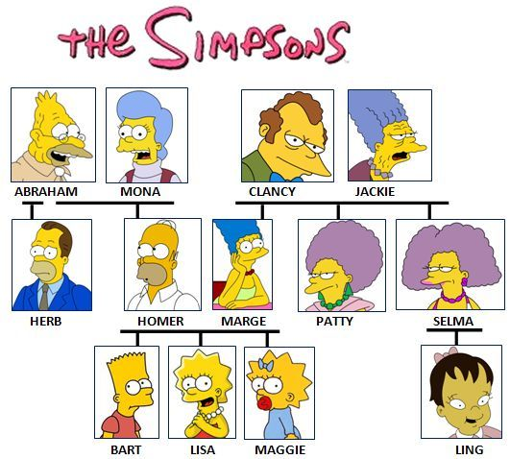

**1) Observa el árbol genealógico y ayuda a Lisa a presentar a su familia. Selecciona alternativa correcta. (8pts)**

[](https://www.google.com/url?sa=i&url=http://es.hellokids.com/c_26630/dibujo-para-ninos/peliculas/dibujos-de-los-simpson/dibujo-de-lisa-simpson&psig=AOvVaw1obYGicbo5nlaFzTnA6s-I&ust=1584539462308000&source=images&cd=vfe&ved=0CAIQjRxqFwoTCOi6vdPToegCFQAAAAAdAAAAABAD)

**Hi! My name is Lisa and this is my family.**

1. **This is Abraham. He is my ____________________.**
2. Uncle b) Grandpa c) brother d) father
3. **This is Maggie. She is my ______________________.**
4. Mother b) Aunt c) Sister d) Grandma
5. **This is Ling. She is my ___________________.**
6. Cousin b) Sister c) Mother d) Aunt
7. **This is Homer. He is my___________________.**
8. Uncle b) Father c) Grandpa d) Brother
9. **This is Bart. He is my ____________________.**
10. Uncle b) Grandpa c) brother d) father
11. **This is Patty. She is my ______________________.**
12. Mother b) Aunt c) Sister d) Grandma
13. **This is Marge. She is my ___________________.**
14. Cousin b) Sister c) Mother d) Aunt
15. **This is Clancy. He is my___________________.**
16. Uncle b) Father c) Grandpa d) Brother

9

20

NUMBERS

**Realiza la operación matemática y selecciona el resultado correcto. (7 pts)**

1. **25+59= ___________**
2. Fourty-eight b) Eighty-four c) Eighty-six d) Seventy-four
3. **98:2= ___________**
4. Fifty-nine b) Ninety-two c) Fourty-six d) Fourty-nine
5. **95-43 = ___________**
6. Fourty-two b) Fifty-four c) Fifty-two d) Seventy-two
7. **100- 35: ___________**
8. Sixty-five b) Fifty c) Thirty-five d) Sixty-four
9. **35+26= ___________**
10. Sixty-one b) Eighty-three c) Twenty-six d) Seventy-four
11. **36 x 2= ___________**
12. Eighty-two b) Twenty-seven c) Seventy- two d) Seventy-four
13. **52+48= ___________**
14. One hundred b) Eighty-nine c) Ninety d) Two hundred

[](https://www.google.com/url?sa=i&url=http://bodum.westernscandinavia.org/clipart-calendar/&psig=AOvVaw1V1UvLT85982N1dZzpt3Cw&ust=1584534769293000&source=images&cd=vfe&ved=0CAIQjRxqFwoTCPiP7pTCoegCFQAAAAAdAAAAABAJ)

DAYS OF THE WEEK AND MONTHS OF THE YEAR

**Contesta las preguntas sobre días y meses seleccionando la alternativa correcta. (14 pts.)**

Days of the Week ( *before: antes after: después)

16)What day is before Saturday? ____________________. a) Sunday b) Monday c) Friday d) Tuesday

17) What day is after Wednesday? __________________. a) Thursday b) Sunday c) Tuesday d) Monday

18) What day is after Sunday? ______________________. a) Friday b) Monday c) Thursday d) Tuesday

19)What day is after Tuesday? ______________________. a) Tuesday b) Friday c) Monday d) Wednesday

20) What day is after Monday? _____________________. a) Tuesday b) Thursday c) Sunday d) Saturday

21) What day is before Sunday? _____________________. a) Sunday b) Saturday c) Friday d) Tuesday

22)What day is after Saturday? ______________________. a) Wednesday b) Monday c) Sunday d) Tuesday

Months of the year

23)What is the first month? ____________________. a) March b) April c) January d) May

24) What is the seventh month? ________________. a) July b) June c) May d) September

25) What is the fourth month? _____________________. a) January b) April c) December d) March

26)What is the second month? ______________________. a) March b) October c) February d) April

27) What is the eighth month? _____________________. a) August b) July c) September d) October

28) What is the eleventh month? ____________________. a) September b) October c) November d) December

29)What is the ninth month? ______________________. a) April b) September c) October d) January

[](https://www.google.com/url?sa=i&url=https://www.clipartkey.com/view/bJhTmi_employed-people-icon-jobs-clipart/&psig=AOvVaw1X9He5MGaVHX41PTR3sYHK&ust=1584541447011000&source=images&cd=vfe&ved=0CAIQjRxqFwoTCLj02oPboegCFQAAAAAdAAAAABAD)

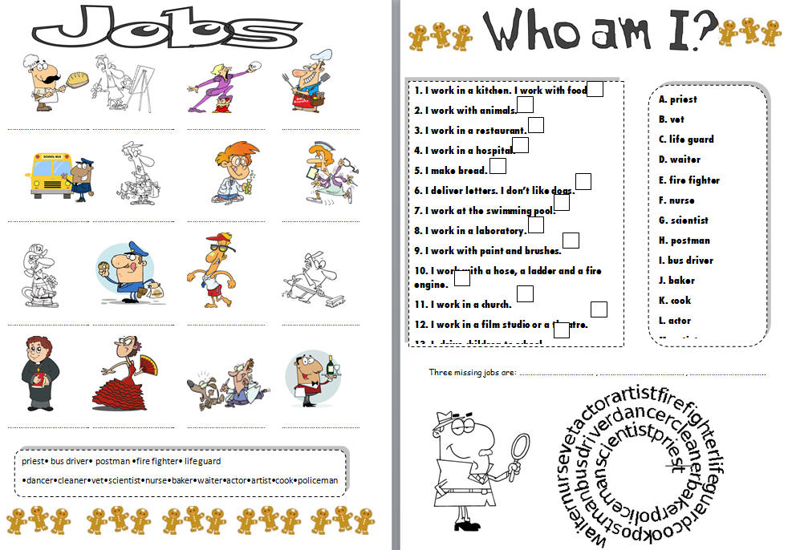

**Lee la definición y selecciona el trabajo al cual corresponde. (7 pts.)**

**30) Someone who flies airplanes.**

1. teacher b) pilot c) butcher d) doctor

**31) Someone who helps sick animals.**

1. Pilot b) secretary c) nurse d) vet

**32) Someone who specializes in teeth**.

1. Dentist b) teacher c) chef d) butcher

**33) Someone who works in an office answering the phone, make appointments.**

1. Pilot b) secretary c) teacher d) vet

**34) Someone who cooks food in restaurants.**

1. Dentist b) tailor c) teacher d) chef

**35) Someone who educates students.**

1. butcher b) pilot c) teacher d) doctor

**36) Someone who helps sick people and helps to the doctor.**

1. nurse b) vet c) tailor d) chef

HOJA DE RESPUESTA

Escriba sus respuestas aquí. LETRAS EN MAYÚSCULA.

|  |  |  |  |  |  |  |  |  |  |  |
| --- | --- | --- | --- | --- | --- | --- | --- | --- | --- | --- |
| **MULTIPLE CHOICE ANSWERS** | | | | | | | | | | |
| **ALTERNATIVAS** | **1** | **2** | **3** | **4** | **5** | **6** | **7** | **8** | **9** | **10** |
|  |  |  |  |  |  |  |  |  |  |
| **11** | **12** | **13** | **14** | **15** | **16** | **17** | **18** | **19** | **20** |
|  |  |  |  |  |  |  |  |  |  |
| **21** | **22** | **23** | **24** | **25** | **26** | **27** | **28** | **29** | **30** |
|  |  |  |  |  |  |  |  |  |  |
| **31** | **32** | **33** | **34** | **35** | **36** |
|  |  |  |  |  |  |