ENGLISH WORKSHEET – 9 TH GRADERS
STUDENT’S NAME | CLASS
 | 1°
TEACHER: Natalia Domínguez C – Estephanie Morales F.
UNIT: Nivelación
CONTENIDOS
Comprensión lectora, Gramática: Will, vocabulario: weather .
OBJETIVOS DE APRENDIZAJE
- Reconocen e identificar información general y específica entendiendo la importancia de información entregada en textos simples tales como noticias, reportajes y letreros.
- Identificar estructuras y uso de estructuras de tiempo futuro “Will” en oraciones.
- Identificar vocabulario en relación a clima en oraciones simples.
INSTRUCCIONES
- En caso que tengas dudas al respecto no te olvides de escribir a :
- ndominguez@donboscoantofagasta.cl ( 1°B-D-E)
- emorales@donboscoantofagasta.cl (1°A-C)
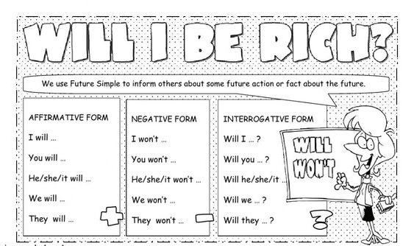

EXERCISES:
Write sentences using “will”. Sentences can be: (✓) = affirmative (✗) = negative answer (?)=questions

Example: 1) Liza/play the saxophone/in a big band/one day. (✓)
Liza will play the saxophone in a big band one day

2) Pearl Jam/come/to your birthday party. (✓)
________________________________________________________________________
3) You/retire/before you are 65. (✗)

________________________________________________________________________
4) He/get/a new job. (?)

________________________________________________________________________
5) They/get/ their first pay check someday. (✓)

________________________________________________________________________
6) We/buy a house this year. (✗)

________________________________________________________________________
7) Our children/go into a space travel. (?)

________________________________________________________________________

VOCABULARY

The weather

- Look at the pictures and red the people’s comments.
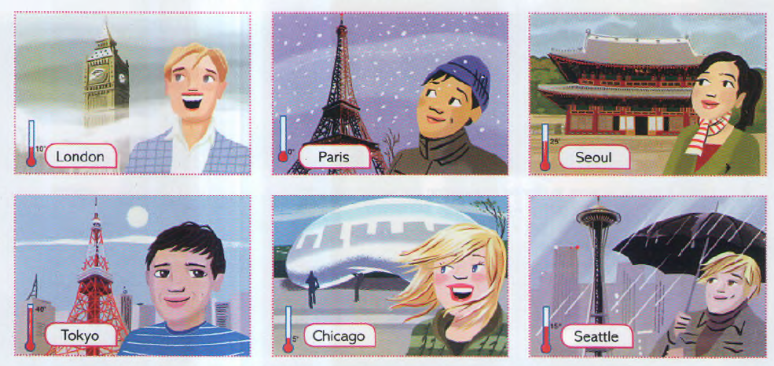
Which cities are they in?
25°

15°

5°

40°

0°

10°

“The weather here is terrible. It’s snowing at the moment” Quique is in PARIS

- “This city is great, but the weather is horrible. It’s raining again today!”
Paul is in _______________.
- “I’m having a great vacation. The weather is always sunny.”
Gabriel is in ________________.
- “The city and the food are fantastic, but the weather is cloudy.”
Claudia is in ________________.
- “Yesterday, the weather was good, but today it’s very windy.”
Jenn is in _______________.
- “The weather is bad again today! It’s foggy and miserable.”
Sam is in _____________________________.

- Look at the thermometers in the pictures in exercise 1. Complete the sentences about the cities with the temperature words.

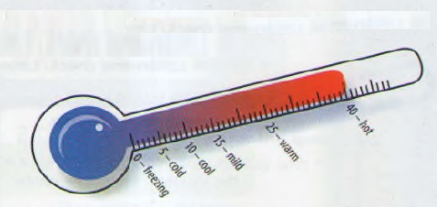
In Chicago it’s COLD.
- In Seattle it’s __________________.
- In Paris it’s___________________.
- In Tokyo it’s ___________________.
- In London it’s __________________.
- In Seoul it’s ___________________.

